**Dear Parents and Students,**

**During this challenging time, the Counseling Department will be** sharing resources that will benefit your student(s), as well as, your family. We **wanted to provide some articles and activities available to you. While we are currently practicing Distance Learning, our Pine Run community remains connected.**

To locate the “Counselor Distance Learning” page, please follow these steps:

1. Go to the Pine Run home page
2. Under the “Our School” tab, click on “Guidance/School Psychologist”
3. Choose “Distance Learning” from the side menu

**We will continue to provide additional resources and activities over the course of the school closure. Please feel free to contact me with any questions and concerns as I will be checking email frequently.**

**Please keep yourselves safe and healthy.  We will get through this together!**

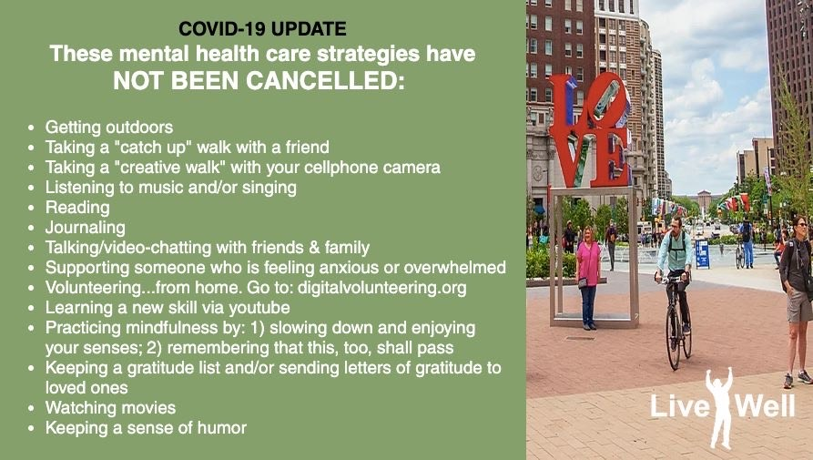

**Sincerely,**

**Michelle (Loh) Fronheiser**

**mfronheiser@cbsd.org**